

**PROJECT**

Project Group members:

Zulaikha Liaqat (089357)

Mubeen Riasat (089292)

Ume-Rubab (089316)

Project Name:

**Library management system**

BS-IT (4TH Semester)

Submitted To:

Prof: Sehrish Khan

v

**Content**

* **Introduction**
* **Scope**
* **Objectives**
* **Frontend**
* **Backend**
* **Framework**
* **ERD**
* **Conclusion**
* **Future work**
* **Mock-up**
* **References**

**Library management system**

* **Introduction**

A library management system (LMS) is a website for college library that simplify and automates the operations of library. It is the online system for library management for students and teachers also. It is the complete system for managing library duties such as purchases, member management, monitoring, storing and calculations.

To solve the traditional issue we build a web development project of library management system using **HTML, CSS, JAVASCRIPT, SQL, and PHP** in which we will be providing user-friendly interface for easy navigation, issuance and return policy, automated tracking of library activities, regular maintenance of book availability record and secure login and access control management by the admin.

The primary objective of an LMS is to properly organize and manage the resource available in library, making it easier for librarians to conduct everybody operations and create a user-friendly experience for users.

* **Scope**

It may help collecting perfect management in details. In a very short time the collection will be obvious simple and sensible. It will help a person to know the management of passed year perfectly and vividly. It also helps in current all work relatives to library management system project. It will reduce the cost of collecting the management and collection produce will go on smoothly.

The project is specifically designed for the use of librarians and library users. The product will work as a complete interface for library management process and library usage from ordinary users.

The project can be easily implemented under various situations. We can add new features as and when we require, making reusability possible as there is flexibility in all the modules.

* **Objectives**

The objectives of library management system (LMS) project to design and implement an efficient and user-friendly system that automates the various tasks associated with managing a library.

Objectives:

* To Efficient book management
* To User-friendly interface
* To Automation of process
* To Inventory management
* To Enhanced research and retrieval
* To User account management
* To Reporting and Analysis
* To Security and access control
* To Integration with other system
* To Scalability

By achieving these objectives, the LMS project aims to enhance the overall efficiency, accessibility, and user satisfaction of the library services, ultimately contributing to an enriched learning and research environment within the institution.

* **Model:**

This “Library management system” project use the waterfall model to design a website.

The waterfall model is:

**Planning**

**Requirement**

**Design**

**Implementation**

We use waterfall model because

* Requirements are well-known, clear and fixed.
* Chances of ambiguity are less so the tale definition is stable.
* Once the product is developed, we can add new more features in the future release.
* Technology is well understood by team due to prior experience.
* **Frontend and backend**
* **Frontend**

We use the basic languages “HTML”, “CSS” and “JavaScript” in the “frontend” of the project “library management system”. Frontend is necessary part in every website because it provides the interface to the user to interact digitally. We write the program in html, CSS and JavaScript language to make the frontend.

**HTML:**

In our website we make the five different files in html to construct our website. Html language provide only structure of your website. For other purpose we use other languages.

**Files are:**

* **Library**

It is the home page of our website. On this front page we set the navigation bar to access the other pages of website.

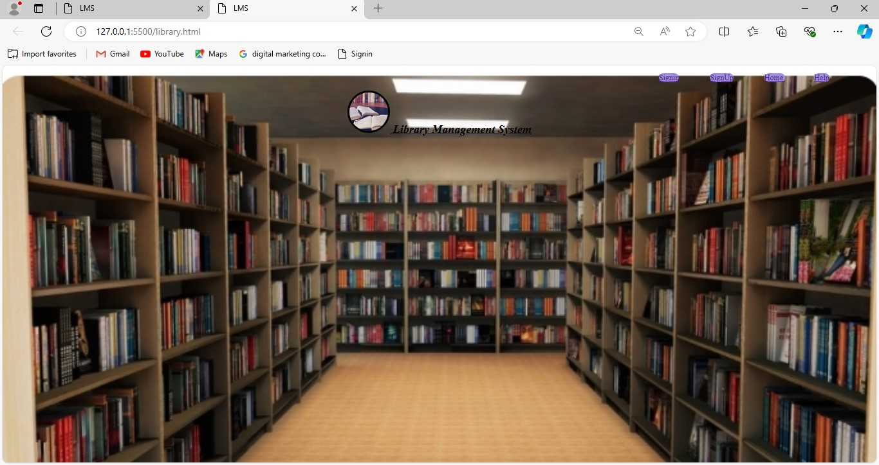

* **Sign In**

In this page we will fill the student data. If any student or teacher want to borrow or return the book in library he must fill this student data form firstly for registration then he/she will borrow or return the book.

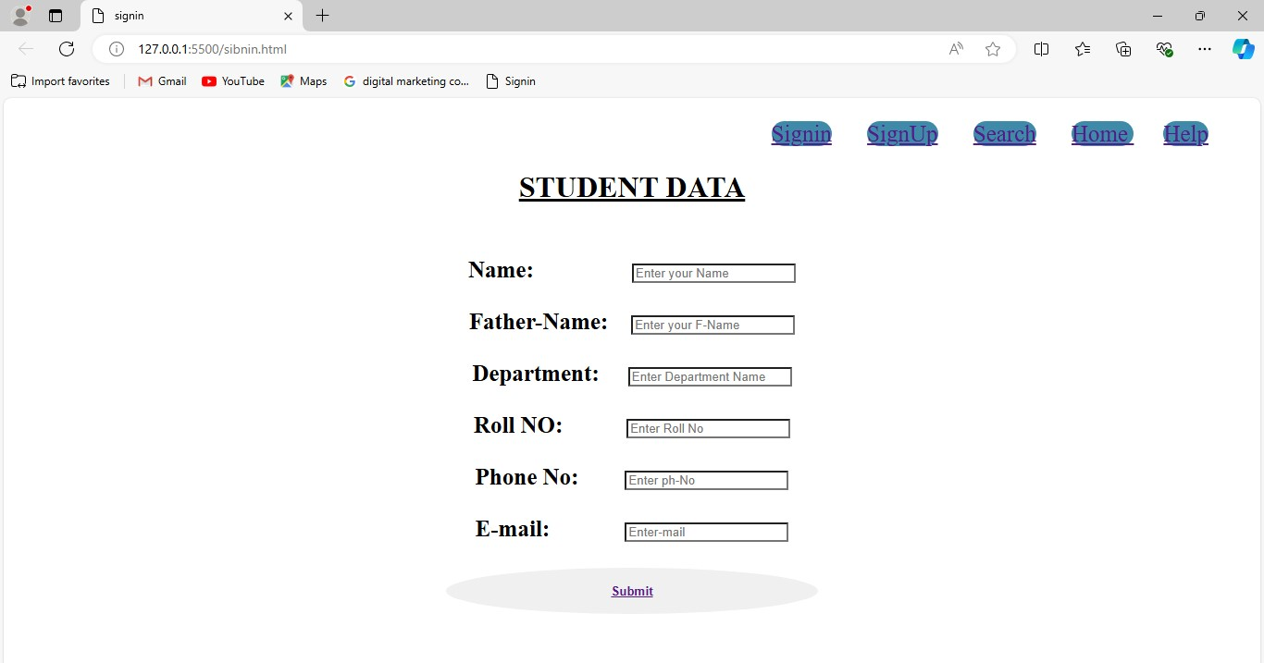

* **Sign up**

It is the sign up page. In this we collect the user information. User must enter his information for library.

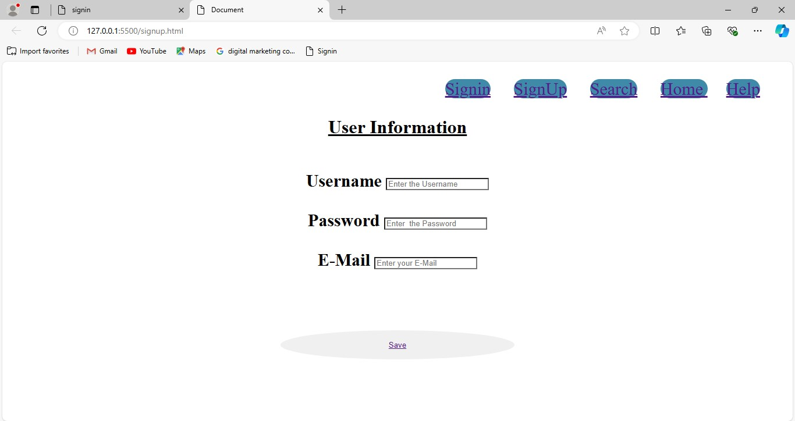

* **SMS (student management system)**

This page will provide the information about all books. If you want to borrow any book, select or choose any book name then you will see the image of book and click on save button then you will borrow any book online from the library.

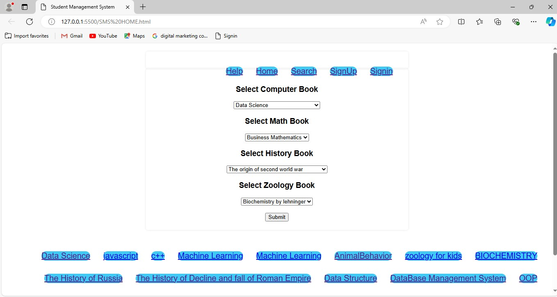

* Help

This file have the code for help of users. In this page you will find the contact no or e-mail address. If you face any issue you will contact or inform to management.

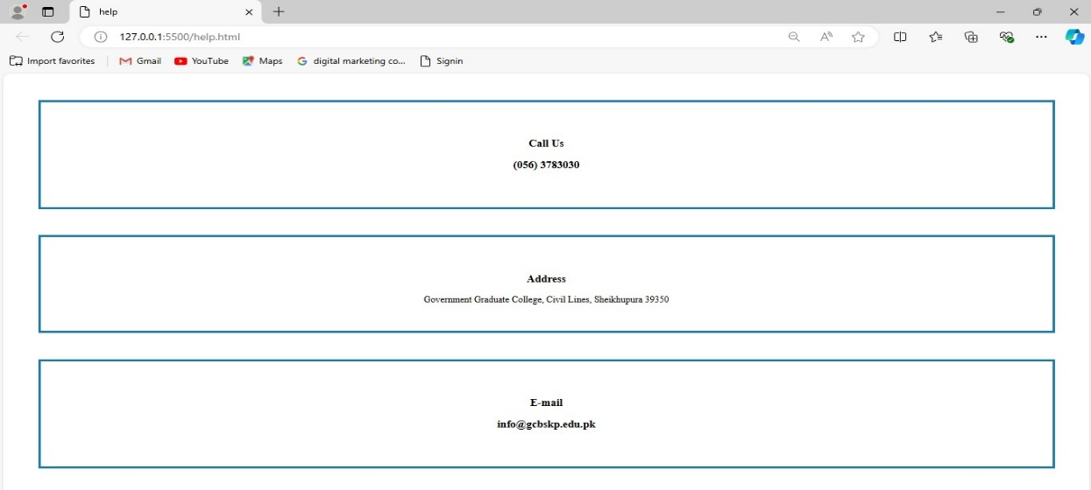

* **CSS**

**CSS** is a language to give styling or add styling in your webpage. You have many ideas to make attractive your page for the user. It will make your html page attractive or decent according to your desire. You can add border, images, colors and padding around your text etc.

In this website “library management system” we use the **CSS** language to make the website attractive for viewers or users.

We make the many CSS files for every html page to make website decent or viewable. In this we add the padding around our text, to give the border or insertion of background image also. You can change your font size or background color also. Except of these things there a lot of properties in CSS that we can use for different purpose.

* **JavaScript**

JavaScript is a scripting or programming language that allows you to implement complex features on the webpage. It is the frontend language but from recent year it is used as backend development also. **JS** allow the user to create and design “dynamic” and interactive webpage to interact visitors and execute the complex actions. It also enables the users to load content into the document without reloading the entire page.

* **Backend**

Procedure of backend is:

**Step 1**

For backend Install XAMPP, then install “mysql” and “apache” in XAMPP.

**Step 2**

Make folder in “documentation” option and make file “index.php” in this file:

1. Add code of php
2. Add the structure of HTML.

**Step 3**

1. Go on browser and search **php myadmin.**
2. Open the demo option.
3. Make database and create tables according to HTML structure.

**Step 4**

1. On the browser and search localhost/name of database.
2. Structure of our page according to php & HTML structure will be open.
3. Insert the user details and submit it.

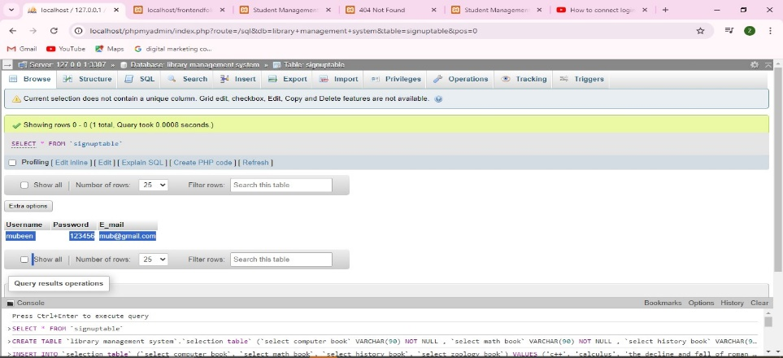

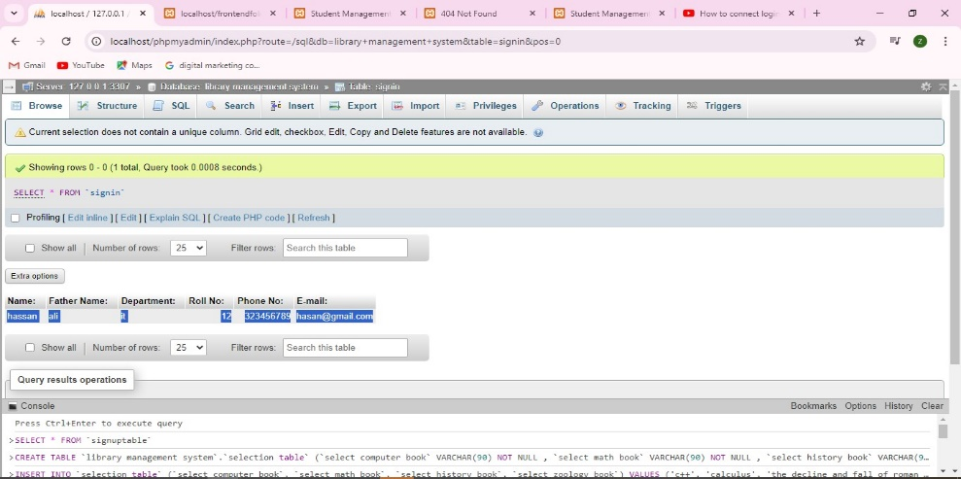

1. Again on another Tab and search the localhost/name of database and see the details that we have been entered in the page.

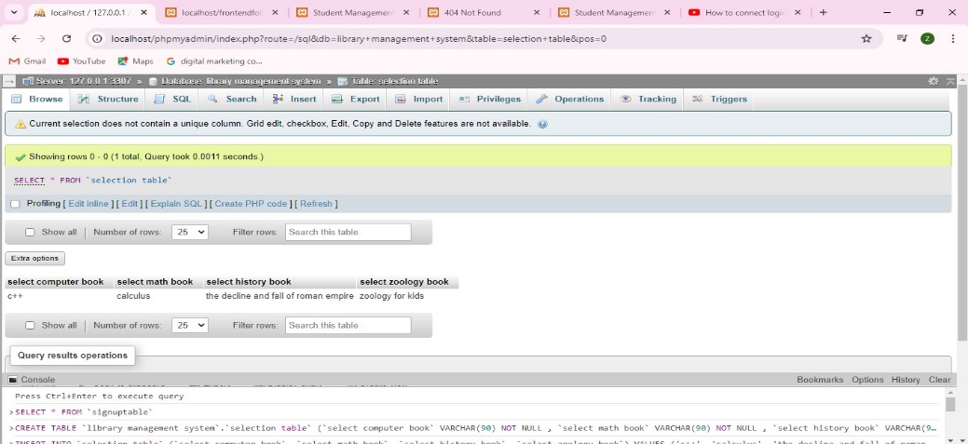

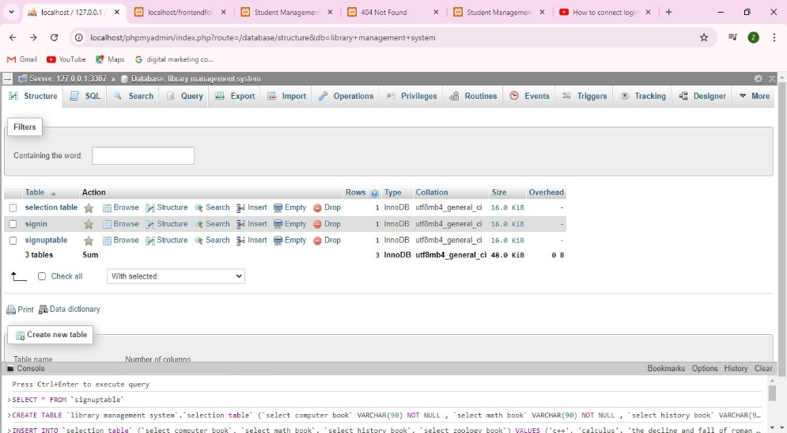

* **Framework**
* For new member for registration:

New member first must fill the form for enter data then click on submit button and after registration user move to search page and can borrow the book.

**User**

**Home**

**Sign In**

**Search book page**

**Submit**

**Enter the data**

**Borrow or return book**

* for user, student or teacher:

Registered person firstly open the website home page will show, then go to sign up page enter your details and then go to books page after this user can borrow or return the book from library.

**User**

**Sign up**

**Click on “Save” button**

**Enter your details**

**Books search**

* **ERD** (entity relationship diagram**)**

I<

**I<**

**II**

**II**

**II**

**II**

**II**

**II**

**I<**

**I<**

**I<**

**I<**

Book

Sign-up

Have

**Account**

Have

Choose

Password

**User**

Enter

Save

Create

Website

* **Conclusion**
* This **library management system** has been computed successfully. It is the user-friendly, and has the required options, which can be utilized by the user to perform the desired operation.
* The software is developed using **php and SQL** as backend.
* The goals that are achieved by website:
* Optimization utilization of resources.
* Efficient management of records.
* Simplification of these operations.
* Less processing time and getting required information
* User friendly.
* Portable and flexible for future enhancements.
* **Futurework**
* Integration with RFID or broadcasting for efficient book tracking.
* Notification system for overdue book and fines.
* Online reservation of books.
* Integration with external databases for expanded book catalogue.
* **Mock-up**

Creating mock-up or library management system website involves the key features and layout of the site. Basic structure is:

* Homepage

Search bars and title

* Sign-In

Student data

* Sign-up

User data

* Search

Information about book, books name and images.

* Help

Phone number

E-mail address

* **References**

Websites from google

* geeksforgeeks.org.
* Slideshare.net

**\*\*\*\*\*\*\*\*\*\***